Usability Test – Colour Scheme
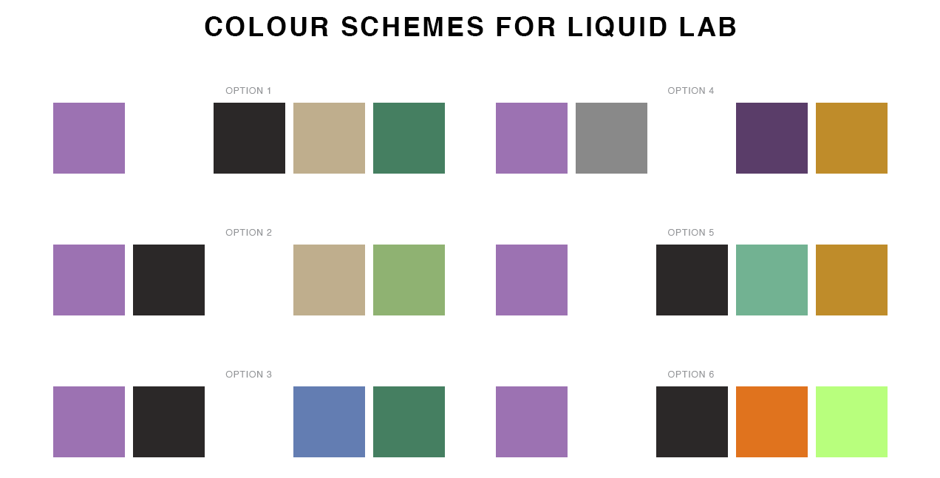

6x colour scheme options provided for testing

3x people that met the target market were interviewed for their thoughts on the colour scheme options.

Questions:
- Which colour schemes appeal to you the most? (select 2 and rank in order of preference)
 | Option 1 | Option 2 | Option 3 | Option 4 | Option 5 | Option 6
Alan |  | 1 | 2
Clarissa | 1 |  |  |  |  | 2
Victoria |  |  | 2 | 1

- Which colour scheme appeals to you the most now that you have heard about the product? (select 2 and rank in order of preference)
 | Option 1 | Option 2 | Option 3 | Option 4 | Option 5 | Option 6
Alan | 2 | 1 | 2
Clarissa |  | 1 |  |  |  | 2
Victoria |  |  |  | 2 |  | 1

- How do the colours in the schemes that you have selected make you feel? (in one or two words for each option that you previously selected)
Option 1 - nature;
Option 2 - organic, clean, calm;
option 3 - fresh;
Option 6 - bright
- Now thinking about the product along with the following keywords: “healthy”, “nutritional” and “high-quality” – does this affect your colour scheme preferences? (select 2 and rank in order of preference)
 | Option 1 | Option 2 | Option 3 | Option 4 | Option 5 | Option 6
Alan | 1 |  | 2
Clarissa | 1
Victoria |  |  |  | 2 | 2 | 1

- Now that I have explained how the choice of colours will be used on the landing page (main, text, background, accents) – what colour schemes best resonate the brand? (select 2 and rank in order of preference)
 | Option 1 | Option 2 | Option 3 | Option 4 | Option 5 | Option 6
Alan | 2 |  | 1
Clarissa | 2 | 1
Victoria |  |  |  | 1 | 2

